Ask Elklit’s presentation: Outcomes of the local workshop Denmark:
hearing impairment
1st EUNAD International
Workshop
Psychosocial Crisis Management -
Assisting individuals with visual/hearing impairment
30th – 31st October, 2013
Prague, Czech Republic

Local Workshop Denmark
Hearing impairment
Professor Ask Elklit
Danish National Centre for Psychotraumatology
University of Southern Denmark

Contents
- Danish National Centre for Psychotraumatology
- Local workshop Denmark: Objectives
- Workshop participants
- Introduction: Ask Elklit
- Presentation: Klaus Huse
- Presentation: Interview participant (qualitative study on hearing impairment)
- Presentation: Helle Berentzen
- Demonstration: Mikkel Andersen, Martin Zimling and Eigil G.R Hvid
- Presentation: Pia Nielsen
- Presentation: Steen Herlev Larsen
- Presentation : Per Jensen, Jeanette From Taubert and Annebrit Hjort
- Evaluation of workshop
- Summary of locally specific problems
- Outcomes
- Questions

Danish National Center for Psychotraumatology
EUNAD STAFF and workshop organizers
Centre Director: Professor Ask Elklit
Research Assistants: Tina Jeppesen & Lotte Skøt
- Part of the Institute for Psychology at the University of Southern Denmark.
- Leading national resource center for Psychotraumatology; working to strengthen research on trauma-related conditions in order to improve prevention and treatment both nationally and internationally.

Local workshop Denmark: Objectives
- One day workshop at the University of Southern Denmark, Odense (12th June, 2013) with representatives from the emergency/rescue services and mental health professions plus one hearing impaired individual.
- Focus: Emergency treatment (first aid) and psychosocial aftercare for hearing impaired individuals in the event of disasters/serious accidents/crises
- Aims:
To identify through the sharing of knowledge and experiences:
  - What we currently know about trauma and trauma-related conditions in the hearing impaired population.
  - How do hearing impaired individuals react to disasters/serious accidents/crises – what specific needs to they have?
  - How can emergency and mental health professionals best help hearing impaired individuals in the event of disasters/serious accidents/crises?
  - Expected outcomes
  - Input for best practice guidelines and recommendations, focusing on locally specific problems and solutions.
  - Creation of Danish Task Force
Workshop participants
- Danish National Center for Psychotraumatology, University of Southern Denmark
  - Ask Elklit: Professor and Center Director
  - Tina Jeppesen: Psychologist and Research Assistant
  - Lotte Skøt: Psychologist and Research Assistant
  - Anders Elbæk Christoffersen: Student Assistant
- National Danish Deaf Association
  - Klaus Huse: Union Consultant
  - Jørgen Sandholt: Sig language interpreter
  - Annebrit Hjort: Nurse
- Capital Region Psychiatry,
Psychiatric Center Ballerup: Deaf Team
  - Per Jensen: Chief consultant
  - Jeanette From Taubert: Head nurse
  - Annebrit Hjort: Nurse
  - Rescue Center Denmark
  - Eigil G.R Hvid: Course Instructor/team coordinator
- The Rescue Workers’ Developmental Secretariat (3F)
  - Mikkel Andersen: Chief, FALCK rescue worker
  - Martin Zimling: Supervisor, FALCK rescue worker

- Danish National Police
  - Steen Herlev Larsen: Police Commissioner at Center for Emergency Communications
  - Lotte Krag: Psychologist and teacher at Police School
- Psychologist Unit, FALCK Health Care
  - Helle Berentzen: Psychologist
- Private Clinic
  - Pia Nielsen: Family- and psychotherapist
- Center for Deaf, Odense
  - Susanne Ørum: Sign language interpreter
- Interview participant: Qualitative study on hearing impairment

Introduction: Professor Ask Elklit
- General information about trauma
  - Psychotraumatology is a new area within psychology
  - What is trauma?
  - The experience of something life threatening
  - The subjective experience
  - The process of being traumatized
  - Identification of traumatized individuals
  - Acute Stress Disorder (ASD) – identification of treatment needs early
  - Posttraumatic stress disorder (PTSD) – reliving/avoidance/hypervigilance
  - Risk of PTSD is dependent on trauma types
  - PTSD over time (3 month window)
  - Chronicity
  - Comorbidity
  - After longer periods of time: personality changes and physical illness
  - Psychological mechanisms associated with trauma
  - Influence of social support

Presentation: Klaus Huse
- Consultant at the Danish Deaf Association
- Presentation took place via a Skype link plus sign language interpreter

- Main points
  - The Danish Deaf Association is working towards making it easier for sign language dependent individuals.
  - Technology has contributed greatly to the minimization of communication barriers – room for improvement.
  - Difficult for hearing impaired individuals to ring emergency services (112) at night: The Capital Region and National Police have established an emergency SMS service; The emergency Management Agency has established an SMS service that sends a warning in the event of a disaster/major accident.
  - Difficult to obtain a sign language interpreter e.g. at the doctor’s surgery and hospitals; some places won’t call for an interpreter; it is often wrongly assumed that the families of hearing impaired individuals can interpret for them; staff should be able to call for an interpreter without having to go through the whole bureaucracy.
  - It is a major burden for hearing impaired individuals to have to insist on getting a sign language interpreter time after time, especially for those who are psychologically weak and lack resources.
  - The psychiatric center in Ballerup is the only place in Denmark that specializes in Deaf psychiatry; The Danish Deaf Association would like to see this offer spread across Denmark.
  - Suggestions for improvement: Smartphone; Trygfonden has recently designed an APP that allows individuals to press a button for help using a GPS function; good idea to develop an APP whereby hearing impaired individuals can communicate – using basic symbols - their name, age, type of accident etc.

Presentation: Interview participant
- Facts about Deaf culture
  - Individuals in the Deaf community consider themselves as being part of a linguistic and cultural minority group; do not like to be referred to as handicapped.
  - Danish sign language is not an international language; use of private (non-accredited) language/grammar.
  - Different levels of Danish language skills; not everybody can read, write and speak Danish.
  - Differences in level of hearing loss – hearing apparatus, Cochlear implant etc.
  - Different ways of communicating in sign language (drawing to speech, sign language, mouth-hand-system, hand alphabet, tactile).
- Recommendations to professionals
  - Basic sign language skills
  - Have a pen and paper ready
  - Remote sign language interpretation?
  - Speak slowly and clearly

Presentation: Helle Berentzen
- Acute Crisis Psychologist at Psychologist Unit, FALCK Health Care.
- Sign language user – often sent out acute situations.
- Conducts therapy with hearing impaired individuals using own sign language skills or via a sign language interpreter.
- Main points
  - Focus on the individual, not the handicap.
  - Use basic signs that symbolize cohesion, help, security etc.
  - Signal values and symbols are extremely important in chaotic situations; logos, orange vest, blanket to signal warmth.
  - Signal values are vital, especially for hearing impaired individuals who tend to be visually oriented.
  - Good idea to learn basic phrases in sign language e.g. “the sign language interpreter is on the way”.
  - Hearing impaired individuals have the same needs as hearing individuals in the therapy situation e.g. closeness, empathy, humor etc.
  - Sign language interpreter is important in the therapy situation; preferable to use same interpreter if multiple sessions are needed.
  - We should encourage ourselves more to work with hearing impaired individuals; we should stop questioning and instead be curious about the many possibilities that exist for working with these individuals.

Demonstration: Mikkel Andersen, Martin Zimling & Eigil G.R Hvid
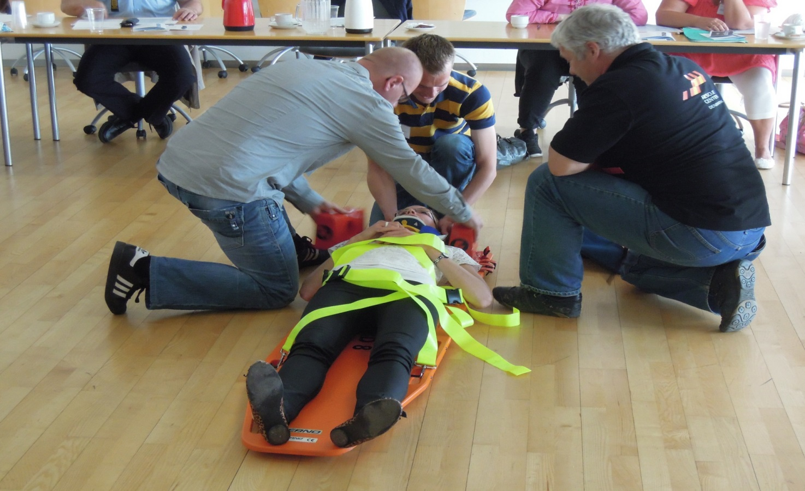

Demonstration: Mikkel Andersen, Martin Zimling & Eigil G.R Hvid
Eigil G.R Hvid: Course Instructor/team coordinator at Rescue Center Denmark
- Mikkel Andersen: Chief, FALCK rescue worker at The Rescue Workers’ Developmental Secretariat (3F)
- Martin Zimling: Supervisor, FALCK rescue worker at The Rescue Workers’ Developmental Secretariat (3F)
- Practical demonstration of how emergency workers communicate with hearing impaired individuals who have been in an accident. Interview participant took part in the demonstration and gave feedback.
  - Interview participant reacted well to the demonstration; it was good that they used signs and that they tried to communicate.
  - Emergency workers receive no education regarding hearing impaired individuals and they rarely come across these individuals in their line of work; important to exchange knowledge and experiences.
  - Easy-to-use electronic patient journals are in the process of being implemented; emergency workers could possibly write down some signs that are relevant to acute situations.
  - Signal values are also hugely important to emergency workers; their uniforms do most of the work.
  - Good idea to provide communications training to emergency workers; sign language is difficult to remember if not maintained; communication should be kept simple e.g. use a folder/poster with simple signs, phrases, pictures etc.

Presentation: Pia Nielsen
- Family- and psychotherapist
- Treats a number of hearing individuals in her private practice
- Fluent in sign language
- Main points:
  - Hearing impaired individuals react the same as hearing individuals during times of crisis;
  - Hearing impaired individuals need to communicate with a professional in their own language (sign language); difficult to lip read in times of crisis; lip reading only functions well for individuals who have already learned the Danish language; writing things down is not optimal in a therapeutic situation.
  - Trauma treatment is difficult if it has to be done through a sign language interpreter; eye contact is extremely important during therapy, and this is lost if one uses an interpreter.
  - Hearing impaired individuals often have latent problems e.g. obsessive thoughts, PTSD etc.; they tend to go around with their problems for a long time and rarely talk about them.
- Discussion among workshop participants:
  - Sign language interpreters are useful in therapeutic situations as long as they remain neutral
  - Feedback from interview participant: it is important that the sign language interpreter is not known to the hearing impaired individual; would prefer to be able to communicate directly (in sign language) with the therapist; would not want a Deaf psychologist/therapist because there is a high risk of meeting them in the hearing impaired community (very small in Denmark)
Presentation: Steen Herlev Larsen

- Police Commissioner at Center for Emergency Communications, National Police
- Demonstration of a system through which hearing impaired individuals can contact the police via SMS.
  - 112 is a mediation center; 3 places in Denmark that process 112 calls; Copenhagen, Slagelse and Aarhus.
  - Aarhus processes all Deaf SMS calls; the number is secret and can only be obtained from various Deaf unions.
  - The Deaf button flashes red and rings because only a very small group of people make use of it (approx. 6-8 calls a year); a chat window appears; the address can be seen from the phone number
  - Deaf messages are forwarded to other areas e.g. health system, police force etc.; it is arranged immediately, so that help can be sent as soon as possible.
  - The system functions well as long as the hearing impaired individual is able to write in Danish.

Presentation: Per Jensen, Jeanette From Taubert & Annebrit Hjort
Presentation 1
- Per Jensen: Chief physician at Capital Region Psychiatry, Psychiatric Center Ballerup - Deaf Team
- Main points
  - Highly specialized function (covering the whole of Denmark) for the treatment of psychiatric disorders among hearing impaired individuals over the age of 18 (primarily sign language users).
  - Hospitalization: Patients usually come from emergency room or other hospitals; integrated into wards for psychiatric rehabilitation; 4 patients hospitalized on average
  - Outpatient treatment: patients usually referred by their GPs or after a visit to the emergency room; they may need to come for a follow-up after hospitalization; approx. 65 patients in treatment.
  - Staff: head nurse, five nurses, a hearing impaired employee (part time), a psychologist, physician (part time); close collaboration with social workers/deaf consultants at Center for Deaf.
  - Psychiatric disorders among hearing impaired individuals: they suffer from the same psychiatric disorders as hearing individuals; reliable studies of prevalence lacking; evidence for generally increased incidence of psychiatric problems in this population; incidence of PTSD not well illuminated.
  - Treatment: supportive conversations derived from narrative principles; cognitive behavioral therapy; possibly medicine (anxiolytic, antidepressive).

Presentation:
Per Jensen, Jeanette From Taubert
& Annebrit Hjort
Presentation 2
- Jeanette From Taubert: Head Nurse at Capital Region Psychiatry, Psychiatric Center Ballerup - Deaf Team
- Annebrit Hjort: Nurse at Capital Region Psychiatry, Psychiatric Center Ballerup – Deaf Team.
- Asked a number of hearing impaired individuals what they would want in a crisis situation:
  - Stay calm.
  - Speak clearly.
  - Body language/gestures
  - Do as they do; use clear facial expressions and explain with hands.
  - Observe their mimes.
  - Physical contact.
  - Communicate in writing.
  - Contact relatives.
  - Call a sign language interpreter.
  - Help them!

Evaluation of workshop
- Participants were asked to fill out an evaluation form after the workshop
- 9 evaluations received
- Summary of evaluations
  - Overall opinion of workshop was GOOD
  - respondents expressed that the workshop contributed to additional knowledge and inspiration in relation to how to handle the situation next time they meet a hearing impaired individual in connection with work.
  - The workshop has highlighted how emergency workers and mental health professionals can communicate with hearing impaired individuals.
  - The workshop has drawn attention to the technical equipment for communication that already exist for hearing impaired individuals.
  - Improvements: our workshop could have reached out to a wider range of emergency- and mental health professionals and hearing impaired individuals if we had videotaped it and arranged for a live feed over the internet.

Evaluation of workshop
- Participants were asked to fill out an evaluation form after the workshop
- 9 evaluations received
- Summary of evaluations
  - Overall opinion of workshop was GOOD
  - respondents expressed that the workshop contributed to additional knowledge and inspiration in relation to how to handle the situation next time they meet a hearing impaired individual in connection with work.
  - The workshop has highlighted how emergency workers and mental health professionals can communicate with hearing impaired individuals.
  - The workshop has drawn attention to the technical equipment for communication that already exist for hearing impaired individuals.
  - Improvements: our workshop could have reached out to a wider range of emergency- and mental health professionals and hearing impaired individuals if we had videotaped it and arranged for a live feed over the internet.
Summary of locally specific problems
- Challenges associated with booking a sign language interpreter in acute crisis situations and at some hospitals and doctors surgery’s.
  - No procedure for this yet.
  - Limited office hours at the booking centers and the “acute booking function” is not always working.
  - This may be a question of financing?
  - Lack of political decisions in the field?
  - Video translation is used very rarely; we need to make the most of the technical opportunities that are out there.
  - Only one place in Denmark that specializes in Deaf psychiatry.
  - Geographical, economic and practical limitations for many hearing impaired individuals.
  - General lack of knowledge about hearing impaired hearing impaired individuals among emergency workers and mental health professionals.
  - Quality training is needed!

Outcomes

- Ideas for best practice guidelines and recommendations.
- Creation of Danish Task Force.
- Work shop may have influenced training at the Police School, National Police. Collaboration between Lotte Krag (psychologist, teacher at the Police School) and Eigil G.R. Hvid (Rescue Center Denmark) regarding emergency help and first aid.
- Media Coverage of the local workshop and the EUNAD project: Ny Viden (New Knowledge Magazine; published), Psykolog Nyt (Psychology New Magazine; out next month) and Hørende (Hearing; out next month).
- Future interviews with some of the workshop participants as a supplement to our Qualitative study on hearing impairment?
Thank you for your attention! Professor Ask Elklit (aelklit@health.sdu.dk)

